18 May 2007 The Weekly Bulletin of Rotary Club of Kathmandu Mid-Town Bc # 46 of 2006-07
Rotary Club of Kathmandu Mid-Town
Breakfast Chatter




District : 3290 Web: www.rotarymidtown.org.np Club Id : 26776

MAY IS THE DISTRICT MONTH
The purpose of the District Leadership Seminar is to develop Rotarian leaders within the district who have the necessary skills, knowledge, and motivation to serve in Rotary beyond the club level. The seminar is open to any interested Rotarians who have served as club president or have served for three or more years in a leadership role. This full-day seminar is held immediately prior to or after the district conference. The following topics are included in the district leadership seminar:
• District Leadership Plan
• Leadership and Motivational Techniques
• Building an International Service Project
• Planning a District Meeting
• Program Electives
• Opportunities in the District and Beyond
Interested Rotarians who have served as club president or have served for three or more years in a leadership role in the club may participate in the dis-trict leadership seminar.

Rtn Er Gyanendra L Pradhan, the Best Manager of the Year 2006 talked on hydropower on national development perspectives at the Club meeting on Friday, 11 May 2007.
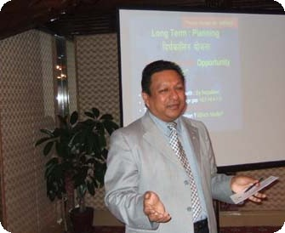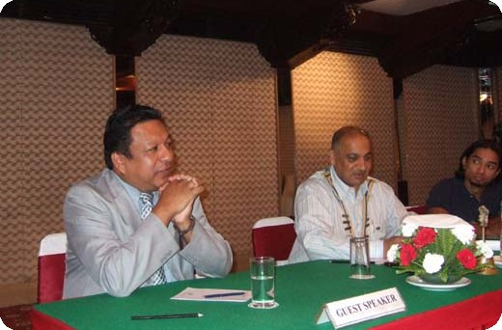
(a) Guest Speaker Er Pradhan giving his presentation; (b) Speaker Gyanendra listening to comments/questions that came from the Club members at the interaction after his presentation while President CK Golchha and Secretary Rabi listening to on-going interactions attentively.

Weekly Meetings and Programs :
Date | Program/Speaker | Program/Topics of Presentation
18 May 2007 | Murali G Ranjitkar | Sharing experience of abduction
25 May 2007 | SSP Basant Kunwar | Drugs as dangerous traps for Nepal
1 June 2007 | Joint meeting | Joint meeting with RC Rajdhani

Friday, 18 May :
Er Murali G Ranjitkar, an engineer of the Agricultural Roads Division, Jawalakhel, and a Rotarian of RC of Dhulikhel will be sharing his experience of being abducted by armed cadres of the Janatantrik Tarai Mukti Morcha led by Jay Krishna Goit. Altogether 4 persons including Er Ranjitkar were abducted from Sakuwa Nanakarpatti VDC on Friday 11 May night when they were on Lahan-Thadi road inspection trip.

Er Ranjitkar along with another abductee Tek Bahadur Lama, a technician, were freed on Sunday, 13 May at Chanhi Chowk in Malahaniya VDC in Saptari in the presence of journalists and right activists.

Annual Club Reporting :
President CK Golchha was on time to submit the Club's annual report to the District Committee for 2006-07 District awards consideration.

Invention Competition, a $25m prize !
British tycoon Sir Richard Branson announced a $25 million prize for the scientist who comes up with a way of extracting greenhouse gases from the atmosphere. The Virgin Group chairman was joined by former Vice President Al Gore and other leading environmentalists, as he announced the challenge to find the world's first viable design to capture and remove carbon dioxide from the air.
A landmark report by the world's leading climate scientists and government officials, published in Paris, warned global warming will continue for centuries, creating a far different planet in 100 years.
Man created the problem, therefore Man should solve the problem," Branson said. "Could it be possible to find someone on Earth who could devise a way of removing the lethal amount of CO2 from the Earth's atmosphere?"
Branson compared it to the competition launched in 1675 to devise a method of estimating longitude accurately. It was 60 years before English clock maker John Harrison discovered an accurate method and received his prize from King George III.
"The Earth cannot wait 60 years. We need everybody capable of discovering an answer to put their minds to it today," said Branson.
Source: The Kathmandu Post

On Lighter Side : Click at the figure ⇩


Vision to see, faith to believe, courage to do…… a perfect representation of what is required of us to be successful in Rotary. We must see the needs around us, believe we can make a difference, and step forward to act.
RI President William B. Boyd

18 May 2007 The Weekly Bulletin of Rotary Club of Kathmandu Mid-Town Bc # 46 of 2006-07

Editor: RR Shrestha, Club Service Director email: rryes@wlink.com.np

